

Visitor Guide
(Last Updated On 8/14/24)

Directions to Athletics Facilities

To Penn State Hazleton Campus (Soccer, Basketball, Volleyball)
FROM THE NORTH: (Wilkes-Barre and Scranton)

Take Interstate 81 South to exit 145. Take a right off the exit ramp, then turn right onto Rt. 93 South. Travel approximately 1/4 to the second traffic light and turn left onto campus.
FROM THE SOUTH: (Pottsville and Harrisburg)

Take Interstate 81 North to exit 145. Turn right onto Rt. 93 South. Travel approximately 1/8 mile to the traffic light and turn left onto campus.
FROM INTERSTATE 80: (From points east and west of Hazleton)

Take Interstate 80 to exit 260A towards Interstate 81 South. Travel approximately 6 miles on Interstate 81 South to exit 145. Take a right off the exit ramp, then turn right onto Rt. 93 South. Travel approximately 1/4 to the second traffic light and turn left onto campus.
Golf Course at the Valley Country Club located at:
79 Country Club Lane, Sugarloaf, PA 18249
To Baseball located at Hazle Township Park (Ball Park Road, Hazle Township, PA 18202)
From Campus:

1. Turn left out of the campus onto Rt. 93 South
2. Proceed for 1 mile to the third traffic light (Blaise Alexander Car Dealership will be on your right) and turn left onto Pecora Blvd
3. At the third stop sign turn right onto Hazle Twp Blvd
4. In approximately 1 mile, turn left onto Ball Park Road

FROM THE NORTH: (Wilkes-Barre and Scranton)

Take Interstate 81 South to Exit 145 (West Hazleton). Take a right off the exit ramp onto Rt. 93 South. Travel approximately 1.4 miles to the fifth traffic light then turn left onto Pecora Blvd (Blaise Alexander Car Dealership will be on your right). At the third stop sign make a right onto Hazle Twp Blvd. Travel approximately 1 mile then turn left onto Ball Park Road then proceed to the parking lot.

FROM THE SOUTH: (Pottsville and Harrisburg)

Take Interstate 81 North to Exit 145 (West Hazleton). Take a right off the exit ramp onto Rt. 93 South. Travel approximately 1.2 miles to the fifth traffic light then turn left onto Pecora Blvd (Blaise Alexander Car Dealership will be on your right). At the third stop sign make a right onto Hazle Twp Blvd. Travel approximately 1 mile then turn left onto Ball Park Road then proceed to the parking lot.

FROM INTERSTATE 80: (East/West)

Take Exit 256 (Conyngham) to Rt. 93 South. Travel approximately 6 miles, then turn left onto Pecora Blvd (Blaise Alexander Car Dealership will be on your right). At the third stop sign make a right onto Hazle Twp Blvd. Travel approximately 1 mile then turn left onto Ball Park Road then proceed to the parking lot.

To Softball located at Freedom Park (70 Mill Mountain Road, Drums, PA 18222)

From Campus:

1. Turn right out of the campus onto Rt. 93 North travel 1.3 miles then turn right onto Banks Avenue
2. At the first stop sign turn left onto South Main Street
3. In 0.3 miles turn right at the flashing yellow light onto Butler Drive
4. Travel 3.3 miles to the first stop then turn left onto N. Old Turnpike Road
5. In 0.4 miles make the first left onto Mill Mountain Road. In 0.2 miles turn left into Freedom Park Softball Complex.

FROM THE NORTH: (Wilkes-Barre and Scranton) - Recommended Route for Buses

Take Interstate 81 South to Exit 155 (Dorrance). Turn left off exit ramp and proceed 1/4 mile to stop sign. Turn right up the hill and proceed 1 mile to PA-309. Turn right onto PA-309 South. Proceed 4 miles on PA-309 South to 3rd traffic signal (Mini-mart on corner), make a right onto West Butler Drive. Continue for 1.6 miles. Turn right onto Mill Mountain Road and proceed 0.4 miles before turning left into the Freedom Park Softball Complex.
FROM THE SOUTH: (Pottsville and Harrisburg) - Recommended Route for Buses

Take Interstate 81 North to Interstate 80 East (Exit 151A). Take Exit 262 (Mountain Top/Hazleton) to PA-309 South. In 4 miles, take a right onto West Butler Drive and continue for 1.6 miles. Turn right onto Mill Mountain Road and proceed for 0.4 miles before turning left into the Freedom Park Softball Complex.
From Interstate 80 (East/West) - Recommended Route for Buses

Take Exit 262 (Mountain Top/Hazleton) to PA-309 South. In 4 miles, take a right onto West Butler Drive and continue for 1.6 miles. Turn right onto Mill Mountain Road and proceed for 0.4 miles before turning left into the Freedom Park Softball Complex.

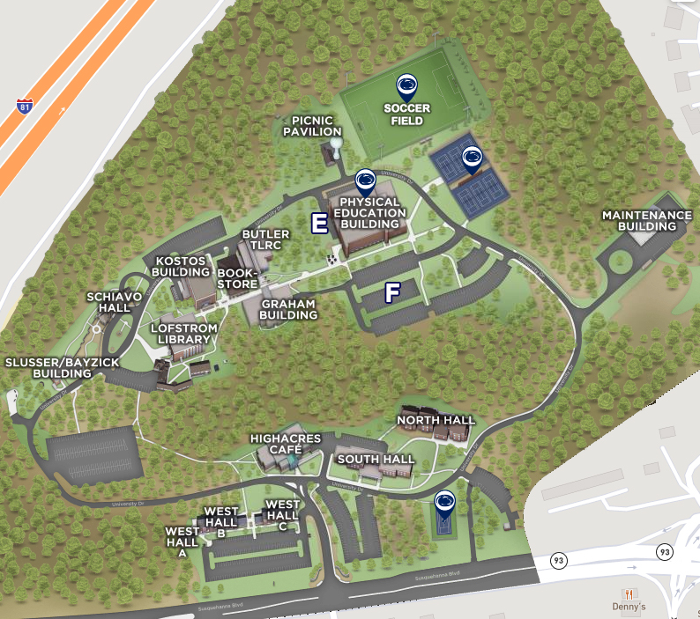
Campus Map and Parking Information
Physical Education Building
Located on the upper level of campus, the Physical Education Building is home to the Dr. Thomas M. Caccese Gymnasium, which houses men’s and women’s basketball as well as the women’s volleyball program.
Soccer Field
Located across the road from the Physical Education Building, the newly renovated Student Athletic and Recreation Field hosts our men’s and women’s soccer programs as well as a variety of intramural and recreation activities.
All guests attending intercollegiate athletic contests at the gymnasium and soccer complex should park in parking lot F designated on the campus map. Accessible parking can be found in parking lot E.

Local Accommodations
Pizza (Delivery)
Alfredo’s Pizza  1346 N Church St.  Hazleton, PA, 18202  3.7 miles from campus  (570) 455-4000 | Vesuvio’s Pizzeria  101 N Wyoming St.  Hazleton, PA 18201  4.6 miles from campus  (570) 454-7021
Dominos  800 N Church St.  Hazleton, PA, 18202  3.9 miles from campus  (570) 455-2000 | Fratelli’s  300 South Main Street  Conyngham, PA 18219  2.9 miles from campus  (570) 788-929-4253

Fast Food / Restaurants
Damon’s Grille  10 Woodbine St.  Hazleton, PA 18202  0.1 miles from campus  (570) 453-0400 | Applebee’s Grill & Bar  2 Weis Ln  West Hazleton, PA 18201  2.4 miles from campus  (570) 450-6674
McDonald’s  571 Susquehanna Blvd  Hazle Township, PA 18202  - miles from campus  (570) 455-8315 | Taco Bell  565 Susquehanna Blvd  Hazlet Township, PA 18202  - miles from campus  (570) 455-4711
Wendy’s  551 Susquehanna Blvd  Hazle Township, PA 18202  - miles from campus  (570) 459-1990 | Popeye’s  556 Susquehanna Blvd  Hazleton, PA 18202  - miles from campus  (570) 861-8135
Panera Bread  564 Susquehanna Blvd  Hazleton, PA 18202  - miles from campus  (570) 710-6009 | Chipotle  543 Susquehanna Blvd  Hazleton, PA 18202  1.7 miles from campus  (272) 223-6000
Denny’s  84 PA Route 93  Hazleton, PA 18202  0.7 miles from campus  (570) 497-4339 | Perkins Restaurant & Bakery  50 PA Route 93  Hazleton, PA 18202  0.9 miles from campus  (570) 455-0313
Sheetz (2 locations)  551 PA Route 93, Sugarloaf, PA 18249  2.7 miles from campus (570) 788-5213  101 Airport Road, Hazle Twp., PA 18202  2.6 miles from campus (570) 497-4450 | Buddies Bagels (Breakfast & Lunch Only)  181 Susquehanna Blvd  Hazleton, PA 18202  2.2 miles from campus  (570) 455-0900

Lodging
Fairfield Inn & Suites by Marriot  1 Woodbine St.  Hazleton, PA, 18202  0.1 miles from campus  (570) 453-0300 | Comfort Inn & Suites  58 PA-93  Hazleton, PA, 18202  0.8 Miles from campus  (570) 455-9300
Hampton Inn Hazleton  1 Top of the 80’s Rd  Hazle Township, PA 18202  1.0 miles from campus  (570) 454-3449 | Candlewood Suites Hazleton  9 Bowman’s Mill Rd.  Hazleton, PA, 18202  1.2 Mile form campus  (570)459-1600

